LabWork1 Database
Kalmakanova Aizere
Part 1: Key Identification Exercises
Task 1.1 — Relation A: Employee

Employee(EmpID, SSN, Email, Phone, Name, Department, Salary)
Sample data:
EmpID | SSN | Email | Phone | Name | Department | Salary
101 | 123-45-6789 | john@company.com | 555-0101 | John | IT | 75000
102 | 987-65-4321 | mary@company.com | 555-0102 | Mary | HR | 68000
103 | 456-78-9123 | bob@company.com | 555-0103 | Bob | It | 72000

- List at least 6 different superkeys
- {EmpID}
- {SSN}
- {Email}
- {Phone}
- {EmpID, Name}
- {EmpID, Department}
- Identify all candidate keys
- EmpID
- SSN
- Email
- Which candidate key would you choose as primary key and why?
EmpID. Because it is a simple, stable identifier specifically used to identify an employee.
- Can two employees have the same phone number? Justify your answer based on the data shown.
Yes, two employees can have the same phone number because the assignment does not state that phone numbers must be unique. The sample dat only happens to show different phone numbers.

Relation B: Course Registration
- Primary Key:
(StudentID, CourseCode, Section, Semester, Year)
- 1. StudentID — identifies the student.
2. CourseCode — identifies the course.
3. Section — identifies the specific course section.
4. Semester — a student can take the same course in different semesters.
5. Year — distinguishes the same semester across different years.
- Additional Candidate Keys:
None can be determined from the given business rules.

Task 1.2: Foreign Key Design

Child Table | Foreign Key | Parent Table | Referenced Key | Reason
Student | AdvisorID | Professor | ProfID | Student's advisor
Course | DepartmentCode | Department | DeptCode | Course's department
Department | ChairID | Professor | ProfID | Department's chair
Enrollment | StudentID | Student | StudentID | Enrolled student
Enrollment | CourseID | Course | CourseID | Enrolled course
Foreign Key Relationships:
- Student.AdvisorID → Professor.ProfID
- Course.DepartmentCode → Department.DeptCode
- Department.ChairID → Professor.ProfID
- Enrollment.StudentID → Student.StudentID
- Enrollment.CourseID → Course.CourseID

Part 2: ER Diagram Construction
Task 2.1: Hospital Management System
- Entities
Entity | Type | Primary Key
Patient | Strong | PatientID
Doctor | Strong | DoctorID
Department | Strong | DepartmentCode
Appointment | Strong | AppointmentID
Prescription | Strong | PrescriptionID
Hospital Room | Weak | (DepartmentCode, RoomNumber)
- Identify all attributes for each entity (classify as simple, composite, multi-valued, or derived)
Patient
- PatientID (Simple, PK)
- Name (Simple)
- Birthday (Simple)
- Address — composite:
- Street
- City
- State
- ZIP
- PhoneNumber — multivalued
- InsuranceInformation — simple
Doctor
- DoctorID — simple, PK
- Name — simple
- Specialization — multivalued
- PhoneNumber — simple
- OfficeLocation — simple
Department
- DepartmentCode — simple, PK
- Name — simple
- Location — simple
Appointment
- AppointmentID — simple, PK
- DateTime — simple
- PurposeOfVisit — simple
- Notes — simple
Prescription
- PrescriptionID — simple, PK
- Medication — simple
- Dosage — simple
- Instructions — simple
Hospital Room
- RoomNumber — simple, partial key
- DepartmentCode — identifying/owner key
Composite PK: (DepartmentCode, RoomNumber) There are no derived attributes.

3. Identify all relationships with their cardinalities (1:1, 1:N, M:N)

Relationship | Cardinality | Explanation
Department — Hospital Room | 1:N | One department has many rooms
Patient — Appointment | 1:N | One patient can have many appointments
Doctor — Appointment | 1:N | One doctor can have many appointments
Patient — Doctor | M:N | Resolved through Appointment
Patient — Prescription | 1:N | One patient can receive many prescriptions
Doctor — Prescription | 1:N | One doctor can prescribe many prescriptions
Department — Doctor | 1:N | One department can have multiple doctors

4. Draw the complete ER diagram using proper notation

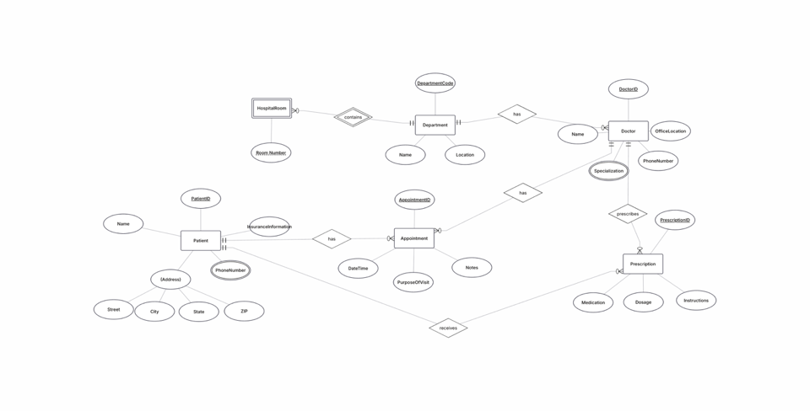

5. Mark primary keys
Primary keys are marked with underline.

Task 2.2: E-commerce Platform

1. Create a complete ER diagram
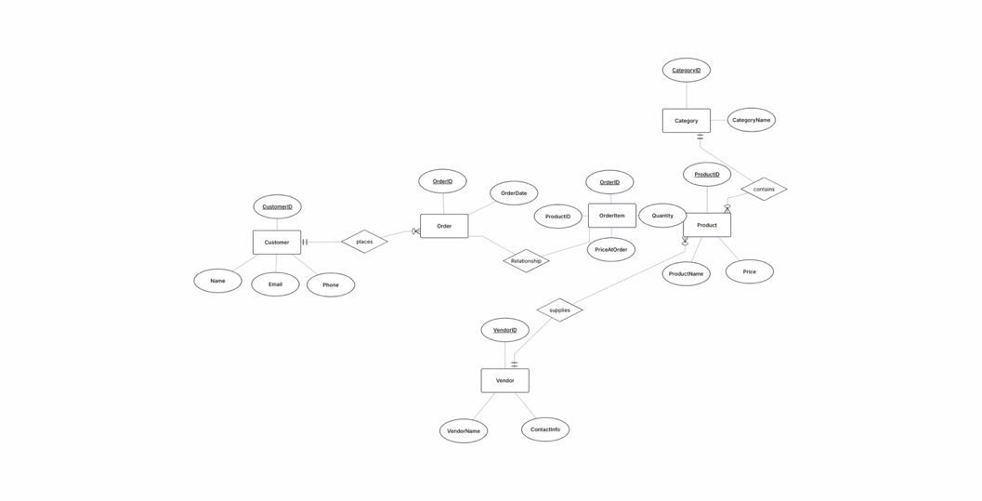

- Identify at least one weak entity and justify why it’s weak
OrderItem is a weak entity because it cannot be uniquely identified without Order and Product. Its primary key is (OrderID, ProductID).

- Identify at least one many-to-many relationship that needs attributes
Order–Product is a many-to-many relationship. It is resolved by the OrderItem entity, which has the attributes Quantity and PriceAtOrder.
Part 4: Normalization Workshop
Task 4.1: Denormalized Table Analysis
  - Identify functional dependencies: List all FDs in the format A → B
- StudentID → StudentName, StudentMajor
- ProjectID → ProjectTitle, ProjectType, SupervisorID, StartDate, EndDate
- SupervisorID → SupervisorName, SupervisorDept
- (StudentID, ProjectID) → Role, HoursWorked
Primary Key: (StudentID, ProjectID)
  - Identify problems: - What redundancy exists in this table? - Give specific examples of update, insert, and delete anomalies
Redundancy: Student, project, and supervisor information is repeated across multiple rows.
Update anomaly: Changing a supervisor's department requires updating multiple rows.
Insert anomaly: A new project cannot be inserted easily if no student is assigned to it.
Delete anomaly: Deleting the last student assigned to a project can also delete the project's and supervisor's information.
  - Apply 1NF: Are there any 1NF violations? How would you fix them?
No violation. All attributes are atomic.
  - Apply 2NF: - What is the primary key of this table? - Identify any partial dependencies - Show the 2NF decomposition
Primary Key: (StudentID, ProjectID)
Partial dependencies:
- StudentID → StudentName, StudentMajor
- ProjectID → ProjectTitle, ProjectType, SupervisorID, StartDate, EndDate
2NF Decomposition:
- Student(StudentID, StudentName, StudentMajor)
- Project(ProjectID, ProjectTitle, ProjectType, SupervisorID, SupervisorName, SupervisorDept, StartDate, EndDate)
- StudentProject(StudentID, ProjectID, Role, HoursWorked)
  - Apply 3NF: - Identify any transitive dependencies - Show the final 3NF decomposition with all table schemas
Transitive dependency:
ProjectID → SupervisorID → SupervisorName, SupervisorDept
Final 3NF decomposition:
- Student(StudentID, StudentName, StudentMajor)
- Supervisor(SupervisorID, SupervisorName, SupervisorDept)
- Project(ProjectID, ProjectTitle, ProjectType, SupervisorID, StartDate, EndDate)
- StudentProject(StudentID, ProjectID, Role, HoursWorked)
Task 4.2: Advanced Normalization
- Determine the primary key of this table (hint: this is tricky!)
(StudentID, CourseID, TimeSlot, Room)
2. List all functional dependencies
- StudentID → StudentMajor
- CourseID → CourseName
- InstructorID → InstructorName
- (TimeSlot, Room) → Building
- (CourseID, TimeSlot, Room) → InstructorID
- (CourseID, TimeSlot, Room) → InstructorName
- Check if the table is in BCNF
Not in BCNF.
Violations include:
- StudentID → StudentMajor
- CourseID → CourseName
- InstructorID → InstructorName
- (TimeSlot, Room) → Building
The determinants are not superkeys of the original relation.
- If not in BCNF, decompose it to BCNF showing your work

- Student(StudentID, StudentMajor)
- Course(CourseID, CourseName) \
- Instructor(InstructorID, InstructorName)
- RoomSchedule(TimeSlot, Room, Building)
- CourseSection(CourseID, TimeSlot, Room, InstructorID)
- Enrollment(StudentID, CourseID, TimeSlot, Room)
- Explain any potential loss of information in your decomposition
The decomposition is lossless if the stated functional dependencies and foreign-key relationships are maintained. The original information can be reconstructed by joining the decomposed tables.

Part 5: Design Challenge
Task 5.1: Real-World Application
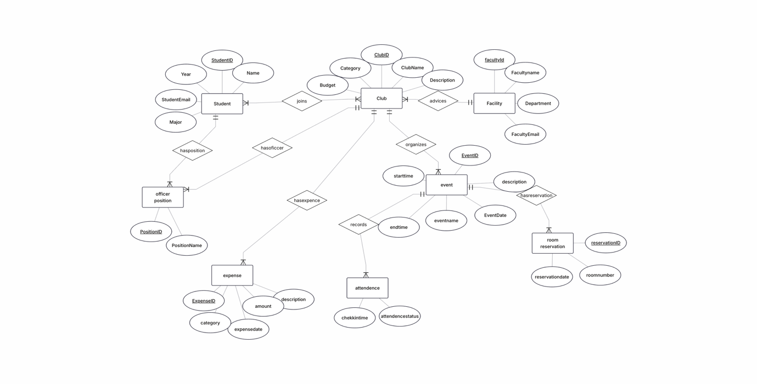
  - Relational schema: Student(StudentID, Name, Email, Major)
FacultyAdvisor(AdvisorID, Name, Department)
Club(ClubID, ClubName, AdvisorID*, Budget)
Membership(StudentID*, ClubID*, JoinDate, OfficerRole)
Event(EventID, ClubID*, EventName, DateTime, RoomID*)
Room(RoomID, Building, Capacity) Attendance(StudentID*,
EventID*, Status)
Expense(ExpenseID, ClubID*, Amount, Date, Description)

3. Identify at least one design decision where you had multiple valid options and explain your choice
Design decision: How to represent officer positions.
There are two valid options:
- Store the position directly in CLUB_OFFICER, for example:
Position = "President"
- Create a separate OFFICER_POSITION entity containing PositionID and PositionName.
I chose the second option because it avoids repeating position names and makes the database more consistent. For example, "President" is stored once in OFFICER_POSITION and referenced using PositionID.
This also makes it easier to add new positions such as Vice President, Treasurer, Secretary, or Event Coordinator without changing the database structure.

4. Write 3 example queries that your database should support (in English, not SQL)
- “Find all students who are officers in the Computer Science Club, including their officer positions.”
- “List all events scheduled for next week with their room reservations and room capacities.”
- “Show the total budget, total expenses, and remaining budget for each student club.”

